1. **Introduction**

The growing significance of artificial intelligence (AI) in healthcare customer relationship management (CRM) systems is a key area of exploration. Researchers are creating frameworks to understand how healthcare businesses can leverage AI-powered CRM systems. One such framework utilizes a "hybrid fuzzy decision-making approach" that incorporates both quantifiable and less quantifiable factors influencing healthcare organizations' decisions regarding AI-integrated CRM systems adoption [1]. This framework addresses the data scarcity surrounding the use of AI-powered CRM systems in healthcare, aiming to bridge this knowledge gap through a comprehensive decision-making tool. Hospitality principles are gaining traction in healthcare settings, emphasizing the importance of a service-oriented approach. Studies suggest that ensuring service assurance, which guarantees the quality of care, and cultivating a social presence to foster positive patient relationships are crucial for providing friendly healthcare. This focus on hospitality aligns with the growing recognition of patient experience as a vital component of healthcare delivery. By implementing strategies that prioritize service quality and build rapport between healthcare workers and patients, basic hospitality principles can significantly enhance the patient experience [2].

Social CRM (SCRM) is another area of interest, with studies exploring its implementation in the healthcare sector. SCRM offers a more comprehensive approach to customer relationship management compared to traditional CRM systems by utilizing social media platforms. Research investigating the Iraqi healthcare sector sheds light on the motivations behind healthcare businesses' decisions to adopt social CRM and the subsequent impact on their operations and patient relationships [3]. This study provides valuable insights specific to the Iraqi healthcare industry. CRM implementation has been shown to cultivate a service-oriented culture within hospitals, leading to improvements in patient experience and satisfaction. Reviews analyzing the impact of CRM on hospitals highlight its potential to enhance various aspects, including patient engagement and communication, healthcare service customization, and fostering stronger patient-hospital relationships. Ultimately, CRM can contribute to creating a healthcare environment that prioritizes patient needs and services [4].

The complexities surrounding hospitals' adoption of CRM systems are also being addressed. Research acknowledges the intricate interplay between organizational and information system factors during hospital decision-making processes regarding CRM implementation. Hung et al. emphasize the significance of organizational considerations such as senior management commitment, well-defined CRM implementation goals, and a corporate culture receptive to change. From an information systems perspective, the study underscores the importance of user-friendliness, data integration capabilities, and system features tailored to address specific hospital needs. These interrelated factors significantly influence the effectiveness of hospital CRM system adoption and implementation [5].

Data quality is another crucial aspect of successful CRM system implementation. Studies examine models for monitoring data quality in real-world CRM system deployments. These models acknowledge the trade-off between resource allocation for data quality improvements and the cost-effectiveness of such efforts. The emphasis on practicality in these models offers valuable insights for businesses seeking to optimize their data quality efforts within CRM systems. Notably, the focus on cost-effectiveness makes these models particularly helpful for businesses aiming to strike a balance between resource allocation and data quality improvement within their CRM systems [6].

The potential applications of CRM in the healthcare industry are a developing area of research. Pioneering works have explored how CRM systems can improve patient care through more efficient appointment scheduling, care coordination, and personalized treatment plans. Additionally, these studies investigate how CRM can enhance patient-provider communication, potentially through online patient portals or secure texting functionalities. Ultimately, CRM adoption has the potential to boost patient satisfaction and loyalty by improving communication and strengthening patient relationships. These early discussions by Yina significantly contribute to the evolving conversation on how CRM technology can revolutionize patient experience and healthcare delivery [7].

1. **Literature Review**

This research offers an innovative structure for comprehending the use of artificial intelligence (AI) in CRM systems by healthcare businesses. Because the framework employs a "hybrid fuzzy decision-making approach," it takes into account variables that conventional mathematical techniques might find difficult to quantify. Although they concede that there isn't enough data on the use of AI-powered CRM systems in the healthcare industry, the authors stress the growing significance of these systems. [1]. By offering a thorough decision-making tool that takes into account both concrete and intangible aspects impacting healthcare businesses' adoption of AI-integrated CRM systems, their approach seeks to close this gap.

The significance of hospitality concepts in promoting a service-oriented attitude in healthcare settings is examined in this essay. According to the authors, the secret to offering friendly healthcare is to ensure service assurance, which guarantees the quality of care, and to cultivate a social presence, which creates positive relationships with patients. This emphasis on hospitality is in line with the expanding understanding that patient experience is an important component of healthcare provision. The authors suggest that by putting into practice tactics that ensure service quality and foster pleasant relationships between healthcare workers and patients, basic hospitality principles can improve the patient experience. [2]

The implementation of social CRM (SCRM) in the Iraqi healthcare sector is the subject of this study. Compared to standard CRM systems, social CRM provides a more involved approach to customer relationship management by utilizing social media platforms. The study's focus on the Iraqi healthcare sector as a particular industry and geographic area provides insightful information[3]. The study looks at the reasons healthcare businesses made the decision to use social CRM and how it affected their day-to-day operations and relationships with patients.

This review analyses how CRM helps hospitals develop a service-oriented culture. The authors contend that by encouraging a more service-focused approach to healthcare delivery, CRM deployment can improve patient experience and satisfaction[4]. The review underscores the potential of CRM to enhance various elements, including patient engagement and communication, healthcare service customisation, and fostering stronger patient-hospital connections. In the end, CRM can help create a healthcare environment that is more focused on the needs of patients and services.

Utilizing a "hybrid fuzzy decision-making approach," this research proposes an innovative framework for examining how healthcare organizations implement CRM systems that include artificial intelligence (AI). The approach recognizes that both easily quantifiable and less easily quantifiable elements play a role in the complexity of decision-making surrounding healthcare CRM implementation. The authors note that there is a dearth of study on the use of AI-powered CRM systems in the healthcare industry, despite the growing importance of these systems in this field. By offering a tool that takes into account both concrete and abstract aspects impacting healthcare organizations' adoption of AI-integrated CRM systems, their methodology seeks to close this knowledge gap [5].

The significant variables impacting hospitals' adoption of CRM systems are examined in this article. The study admits that organizational and information system aspects interact in a complex way when hospitals decide whether to implement CRM systems. Hung et al. stress the significance of elements like senior management commitment, well stated CRM implementation goals, and a change-receptive corporate culture when discussing organizational considerations. From the standpoint of information systems, the evaluation emphasizes the importance of user-friendliness, data integration capabilities, and system features customized to particular hospital needs. The effectiveness of hospital CRM system adoption and implementation is influenced by these interrelated elements [6].

In a real-world CRM system implementation, a model for monitoring data quality is examined in this article. The model may take into account the trade-off between the resources needed to accomplish improvements in data quality and the cost-effectiveness of those improvements. This model has a strong emphasis on practicality and provides insightful information for situations in which businesses want to maximize their efforts in data quality [7]. Notably, because of its emphasis on cost-effectiveness, it is especially helpful for businesses trying to strike the correct balance when it comes to allocating resources and improving data quality inside their CRM systems.

By examining its possible uses in the healthcare industry, Yina's 2010 conference paper advances the still-developing topic of CRM in healthcare. Presumably, the article addresses how CRM systems might be used to enhance patient care by enabling more effective scheduling of appointments, care coordination, and individualized treatment regimens. Furthermore, the study might investigate how CRM can improve patient-provider communication, possibly by utilizing online patient portals or secure texting [8]. Adoption of CRM may boost patient happiness and loyalty by enhancing communication and developing stronger patient relationships. The early conversations on using CRM technology to enhance patient experience and healthcare delivery are greatly enhanced by Yina's work.

In the context of Chinese hospitals in the middle of the 2000s, Yao, Li, and Su's 2005 conference paper presents a distinctive viewpoint on CRM adoption. Given the unique features of the Chinese healthcare system at the time, the study probably looks at how CRM features might help Chinese hospitals with their problems. Enhancing patient communication to lower appointment no-show rates and boost medication adherence, as well as boosting operational efficiency through improved patient data management and appointment scheduling, are possible areas of attention [9]. This study adds to our knowledge of how CRM may be tailored to various healthcare settings and address local issues by looking at the application of CRM technology in Chinese hospitals.

The research by Monem, Sharifian, and Shaterzadeh (perhaps published in 2011) approaches CRM deployment in hospitals holistically by taking patient perspectives and software functionalities into account. This dual viewpoint is essential to comprehending the elements that contribute to the effective implementation of CRM in healthcare environments. Regarding software, the study could investigate the technical features of CRM systems that are relevant to healthcare facilities, including modules for patient relationship management, tools for data analytics, and reporting features. The study may look into things like user-friendliness, patient portal accessibility, and the general effect of CRM on patient satisfaction and communication from the perspective of the patient. This study looks at both patient-centered and technological factors, giving healthcare organizations useful information to improve their CRM implementation plans [10].

In their 2011 convention document, Monem and Behboodian address the organizational aspect of CRM implementation in healthcare facilities. This study is especially pertinent since it comes at a time when the healthcare industry is becoming more and more interested in CRM. Most likely, the paper looks at how hospitals might deal with internal obstacles that arise while implementing CRM. Getting top management support, integrating CRM with current hospital operations, and creating a culture of data-driven decision making are a few possible key areas of concentration [11]. Through the examination of these organizational factors, the study offers healthcare organizations insightful recommendations for using CRM successfully and attaining the targeted enhancements in patient care, communication, and operational effectiveness.

Although Sharma, Rangarajan, and Paesbrugghe's (2020) article concentrates on salesforce resilience within a wider business framework, the idea is applicable to the healthcare sector as well. The authors contend that a sales force that is adaptive and agile is better suited to deal with market upheavals. By encouraging flexibility in all facets of patient relationships, healthcare institutions can implement this idea. To effectively contact patients, for example, healthcare organizations can create flexible communication strategies that make use of a variety of channels, including encrypted messaging, email, and phone calls. Additionally, flexibility in sales strategies can help healthcare sales teams accommodate a range of patient demands and preferences [12]. These teams may be in charge of promoting wellness initiatives or innovative medical technologies.

1. **Problem Definition**

The healthcare landscape is undoubtedly facing significant challenges, with fragmented patient data and low patient engagement standing out as two major obstacles that impede the delivery of optimal care. These issues not only hinder the effectiveness of medical treatments but also contribute to frustration and inefficiency for both patients and healthcare providers.Fragmented patient data presents a considerable barrier to delivering comprehensive and well-informed healthcare. In today's digital age, medical records are often scattered across various systems and platforms, making it difficult for healthcare providers to access a complete and accurate picture of a patient's medical history. This fragmentation can lead to gaps in information, duplicated tests, and delays in treatment, all of which can compromise patient outcomes and satisfaction.

Moreover, fragmented data undermine the ability of healthcare providers to make informed clinical judgments. Without access to a unified and standardized repository of patient information, doctors may struggle to identify patterns, track progress over time, and tailor treatments to individual needs effectively. This lack of comprehensive data integration not only impedes the delivery of timely and appropriate care but also increases the risk of medical errors and adverse events.In addition to fragmented patient data, low patient engagement poses a significant challenge to the healthcare system. Patient engagement refers to the active involvement of individuals in their own healthcare journey, including understanding their conditions, adhering to treatment plans, and making informed decisions about their health. However, many patients lack the necessary tools, resources, and support to fully engage in their care.

As a result, missed checkups, non-adherence to medications, and suboptimal health outcomes are common consequences of low patient engagement. When patients are not actively involved in managing their health, they may miss important appointments, neglect preventive measures, and fail to communicate effectively with their healthcare providers. This can lead to unnecessary complications, avoidable hospitalizations, and increased healthcare costs for individuals and healthcare systems alike.

Furthermore, low patient engagement exacerbates operational inefficiencies within healthcare settings. Hospitals and clinics struggle to deliver high-quality care when patients are disengaged and uninformed about their health. Without active participation from patients, healthcare providers may find it challenging to monitor progress, adjust treatment plans, and provide timely interventions when needed. This can result in missed opportunities for early intervention, delayed diagnoses, and compromised patient safety.

In conclusion, fragmented patient data and low patient engagement are significant obstacles confronting the existing healthcare system. These challenges not only hinder the delivery of comprehensive and well-coordinated care but also contribute to frustration and inefficiency for both patients and healthcare providers. Addressing these issues requires a concerted effort to improve data integration, enhance patient education and empowerment, and foster collaborative partnerships between patients and healthcare providers. By prioritizing these initiatives, we can work towards a healthcare system that is more patient-centered, efficient, and effective for all stakeholders involved.

1. **Objectives**
   1. Make the lives of patients easier: Assist patients in locating information, making appointments, and communicating with physicians conveniently in one location. Use rescheduling options and reminders to cut down on missed appointments.
   2. Simplify hospital operations by automating repetitive processes such as scheduling and refilling to free up staff time. Boost departmental communication and make the best use of available resources.
   3. Improve patient care by centralizing a patient's medical records to enable physicians to make the most informed choices. Make treatment plans according to the requirements of each patient.
   4. Protect and preserve patient data: As required by law, use robust security measures to safeguard patient privacy.
   5. Improve healthcare continuously by using data to identify what is already effective and what needs to be changed to provide better care for patients.

In the realm of healthcare, leveraging technology to enhance patient experiences and streamline operations is paramount. One significant initiative involves centralizing patient services, such as information retrieval, appointment scheduling, and communication with healthcare providers, into a single accessible platform. By providing patients with a convenient and user-friendly interface, they can easily navigate through their healthcare journey without unnecessary hassle. Features like rescheduling options and appointment reminders play a crucial role in reducing missed appointments, thereby ensuring that patients receive timely care and maximizing the efficiency of healthcare facilities.

Automating repetitive tasks within hospital operations is another key aspect of improving overall efficiency. By implementing systems that handle scheduling, medication refills, and other routine processes, healthcare staff can focus their energy on more critical tasks that require human expertise. This not only saves time but also enhances departmental communication and resource utilization, leading to smoother operations and better patient outcomes.

Centralizing patient medical records is fundamental to enhancing the quality of care provided. By consolidating all relevant information into one accessible location, physicians can make more informed decisions about treatment plans tailored to each patient's specific needs. This approachfacilitates collaboration among healthcare professionals and reduces the likelihood of errors or oversights, ultimately leading to better health outcomes for patients.Ensuring the security and privacy of patient data is a non-negotiable aspect of modern healthcare. Strict adherence to legal requirements and the implementation of robust security measures are essential to safeguarding sensitive information. By employing encryption, access controls, and other advanced security protocols, healthcare organizations can mitigate the risk of data breaches and protect patient confidentiality, thereby building trust and confidence in their services.

Finally, continuous improvement in healthcare relies on data-driven insights. By analyzing patient outcomes, treatment efficacy, and operational performance, healthcare providers can identify areas of success and opportunities for enhancement. This iterative process allows for the refinement of care delivery protocols, the adoption of best practices, and the implementation of innovative solutions to address emerging challenges. Ultimately, leveraging data to drive decision-making ensures that healthcare organizations remain adaptable and responsive to the evolving needs of their patient populations, thereby continuously raising the standard of care.

1. **Proposed Method**

**5.1 Transforming Healthcare with Salesforce CRM: Boosting Efficiency, Personalization, and Patient Care**

Salesforce CRM is not just a name in the software world; it's a powerhouse for building strong customer relationships, and its impact extends even to the healthcare sector. Hospitals leveraging Salesforce CRM unlock a treasure trove of benefits that optimize operations, personalize patient experiences, and ultimately, elevate the quality of care delivered.Beyond one-size-fits-all: Healthcare is not a cookie-cutter industry, and neither should your approach to patient care be. Salesforce CRM empowers hospitals to tailor their offerings to individual patient needs and preferences. This ability to personalize treatment plans and services goes a long way in ensuring each patient receives the care that best suits their unique circumstances.[2]

Tailored communication, targeted impact: Gone are the days of generic marketing messages. With Salesforce CRM, hospitals can craft personalized outreach campaigns based on individual patient preferences, medical history, and demographics. This laser-focused approach fosters deeper patient engagement and ensures your marketing efforts resonate on a personal level, leading to improved campaign effectiveness. [3, 8]Happy patients, thriving hospital: At the heart of healthcare lies the patient. Salesforce CRM recognizes this and equips hospitals with the tools to effectively manage and track patient interactions, preferences, and feedback. This translates into personalized, seamless care experiences that leave patients feeling valued and heard. Ultimately, happier patients contribute to a thriving hospital environment, fostering loyalty and positive word-of-mouth recommendations. [4, 9]

Collaboration thrives, communication flows: In the complex world of healthcare, seamless communication and collaboration are paramount. Salesforce CRM acts as a central hub, allowing medical professionals to easily share and access patient data, brainstorm treatment strategies, and effectively communicate with colleagues across departments. This fosters a collaborative environment where expertise is readily shared, ultimately benefiting patient care. [5, 10]

Efficiency at its core: Imagine a centralized platform where your sales team effortlessly manages leads, tracks contacts, and nurtures opportunities. Salesforce CRM brings this vision to life, streamlining workflows and boosting team productivity. This newfound efficiency translates to more time spent connecting with patients and driving successful outcomes. [6, 9]

Data becomes knowledge, knowledge empowers: Imagine a world where patient data is organized, readily accessible, and analyzed efficiently. Salesforce CRM makes this dream a reality. Hospitals can leverage the platform to collect, organize, and analyze patient data securely and effectively. This empowers medical professionals with up-to-date, reliable information, enabling them to make informed decisions and provide the best possible care for their patients. [7, 11] .By embracing Salesforce CRM, hospitals can move beyond traditional healthcare practices and step into a future of optimized operations, personalized care, and empowered patients. It's a win-win for both healthcare providers and the communities they serve.

**5.2 Implementing Salesforce CRM in Hospitals**

Data Security and Privacy: Hospitals are required to maintain compliance with HIPAA rules since healthcare data is extremely sensitive. To secure patient data, Salesforce provides strong security measures and data encryption [10, 11].

System Integration: For smooth data flow and workflow optimization, Salesforce must be integrated with the hospital's current systems, including EHRs and billing systems [6].

Change Management: To guarantee user acceptance and success when implementing a new system, extensive planning and change management techniques are needed [2].

Implementing Salesforce CRM in Hospitals: A Step-by-Step Guide

Step 1: Establishing a Vision and Measurable Objectives

Prior to implementation, establishing a clear vision and measurable objectives is paramount. Hospitals should identify key areas for improvement, whether it be enhancing patient satisfaction through personalized communication (e.g., Poniszewska-Marańda et al., 2019) [4], optimizing

resource allocation and reducing operational errors, or identifying new patient segments to boost revenue and patient loyalty. Quantifiable goals should be established for each objective to track progress and measure the impact of the CRM system [1].

Step 2: Cultivating Collaborative Leadership and Stakeholder Engagement

Change management is crucial for successful CRM integration. Engaging all stakeholders, including physicians, nurses, administrators, and billing staff, fosters buy-in and facilitates adaptation. Tailored communication highlighting the benefits of CRM for each group, from streamlining workflows to improving communication and data accessibility, is essential [2, 3]. This collaborative approach ensures a smooth transition and maximizes the potential of the system [5].

Step 3: Selecting the Optimal Salesforce CRM Edition

Salesforce CRM offers various editions with diverse features and functionalities. A thorough assessment of the hospital's specific needs and budget constraints is necessary to select the most suitable edition. Starting with core functionalities like scheduling, communication tools, and basic data management allows for a gradual learning curve and minimizes disruption [8, 9]. As experience and confidence grow, additional features can be implemented for a more comprehensive solution [3].

Step 4: Ensuring Data Integrity and Security

The foundation of an effective CRM system lies in accurate and organized patient data. Hospitals must meticulously manage patient information, including medical history, insurance details, and demographics. Adherence to HIPAA regulations and data security best practices is paramount to safeguarding patient privacy and ensuring trust [10, 11]. High-quality, accessible data empowers informed decision-making and personalized patient care [7].

Step 5: Streamlining Workflows Through System Integration

Seamless integration with existing hospital systems, such as electronic health records (EHRs) and billing software, eliminates manual data entry, reduces errors, and streamlines workflows. This integration ensures data consistency across systems, allowing healthcare professionals to focus on delivering quality care rather than administrative tasks (e.g., Cloudely, 2023) [6].

Step 6: Empowering Users and Building Champions

Employees are the driving force behind successful CRM adoption. Providing comprehensive training sessions on practical applications like goal setting, appointment scheduling, and record-keeping equips them to utilize the system effectively [12]. Ongoing support and addressing user concerns promptly foster a sense of empowerment and encourage user advocacy, leading to improved system utilization and a positive work environment [3].

Step 7: Implementing a Phased Approach and Piloting for Success

A phased approach minimizes disruption and ensures a smooth transition. Starting with a pilot program involving a limited group of users allows for system testing, feedback gathering, and necessary adjustments before full-scale implementation [5]. This iterative approach fosters confidence and builds momentum for broader adoption [12].

Step 8: Continuously Monitoring, Analyzing, and Adapting

The implementation journey doesn't end with system launch. Ongoing monitoring of key performance indicators (KPIs) such as revenue impact, operational efficiency, and patient satisfaction is crucial. Data analysis helps identify areas for improvement and facilitates strategic adaptations to the CRM strategy [1]. Encouraging user feedback and incorporating stakeholder insights further optimizes the system and maximizes its impact on patient care and hospital performance [4].

By following these research-informed steps and fostering a culture of continuous learning and improvement, hospitals can leverage the power of Salesforce CRM to transform into patient-centric, efficient, and financially sustainable organizations. This strategic approach ensures alignment with best practices and paves the way for achieving the desired outcomes and exceeding expectations in the ever-evolving healthcare landscape.

**5.3 Enhancing Patient Care through Salesforce CRM**

It is challenging to genuinely focus on patients in the healthcare industry because of fragmented data and antiquated procedures. Salesforce CRM is revolutionary since it centralizes data, leverages artificial intelligence to anticipate issues, and facilitates smooth communication [1, 5]. In spite of obstacles and potential future directions, this article delves further into how it might transform patient care, workflow, and communication in the healthcare industry.

Pro’s of CRM in healthcare industry

* + 1. Predictive insights and proactive care: Algorithms powered by AI scan patient data to identify potential health issues and recommend preventative measures. Early intervention is made possible by this proactive strategy, which may improve health outcomes and lower medical expenses. [1, 5]
    2. Personalized communication and engagement: Salesforce CRM's secure messaging platforms and appointment reminders provide smooth communication between patients and providers, promoting engagement and trust. Patients are empowered to actively engage in their care process thanks to the enhanced communication. [2, 3]
    3. Better Patient Happiness and Results: Salesforce CRM has the ability to greatly enhance patient happiness and health outcomes by emphasizing the requirements of the patient, promoting communication, and enabling proactive care. [2, 4]
    4. Centralized Patient Information: Salesforce CRM creates a safe, unified platform that holds all medical information, including appointments, medical history, and preferences. With a more comprehensive understanding of each patient, this 360-degree perspective gives healthcare professionals the ability to create individualized treatment programs and enhance care coordination.[4]
    5. Streamlined Workflows and Operational Efficiency: Salesforce CRM's automated scheduling, billing, and data analysis features save administrative work and give medical personnel more time to concentrate on patient care. [4, 6]

**5.4 Operational Efficiency of Hospitals using Salesforce CRM**

Hospitals are under increasing pressure to provide patients with high-quality care while increasing operational efficiency. This study investigates how the customer relationship management platform Salesforce CRM may be used to solve these issues and transform hospital operations. This study shows how important Salesforce CRM features can improve hospital workflows by examining how they affect them [1, 5].

* + 1. Simplify patient intake and scheduling: AI-powered scheduling, centralized patient data, and automated appointment booking maximize patient flow and cut down on wait times [6].
    2. Boost staff productivity and resource allocation: Real-time data analytics on bed availability, staff workload, and equipment usage allow for greater staff productivity and resource allocation [4].
    3. Boost the management of the revenue cycle: Personalized payment reminders, automated invoicing and claims processing, and patient portal access to financial data all help to simplify revenue collection and lessen administrative workloads. [4, 10, 11]
    4. Increase patient contentment and engagement: Proactive outreach programs, tailored communication channels, and secure messaging systems encourage patient participation and raise patient satisfaction. [2, 3, 8]
    5. Enhance supply chain management: Automated purchase order creation, real-time inventory tracking, and predictive demand forecasting reduce inventory costs and guarantee effective supply chain operations [6].

The research additionally looks at the possible obstacles to implementing Salesforce CRM, like connectivity with previous systems, user adoption obstacles, and data security issues. It also looks at the technology's potential applications in the future, such as AI-powered clinical decision assistance, hospital equipment predictive maintenance, and customized patient care pathways.

The goal of this study is to show how Salesforce CRM can improve hospital operational effectiveness, which will ultimately result in better financial results, better patient care, and a more reliable healthcare system.

**5.5 Data Management in Hospitals with Salesforce CRM**

Effective data management is essential in the quickly changing healthcare environment to meet strict regulatory requirements, streamline operations, and deliver better patient care [8, 9]. Hospitals looking to fully improve their data management procedures will find that Salesforce Customer Relationship Management (CRM) is a potent answer. Salesforce CRM effortlessly unifies electronic health records, appointment scheduling, and billing systems into a single platform by centralizing patient data. This consolidation promotes a more comprehensive and informed approach to decision-making by facilitating collaboration among healthcare practitioners.

Additionally, the communication tools in Salesforce CRM support smooth interactions between staff, administrators, and healthcare providers [2]. This lowers the possibility of mistakes and guarantees prompt patient care, improving overall operational effectiveness. By automating repetitive operations, the platform's workflow automation features let healthcare workers free up critical time to concentrate on providing individualized and attentive patient care [4].

Hospitals may use Salesforce CRM's powerful analytics features to get meaningful insights from their data. For the purpose of managing diseases, this involves analyzing patient outcomes, resource use, and operational effectiveness. This allows for data-driven decision-making and predictive modeling. Through safe access to health information via portals and mobile applications, as well as individualized communication channels, the platform also improves patient involvement. [3, 8]

In the healthcare industry, maintaining regulatory compliance is crucial. Salesforce CRM helps with this difficulty by providing extensive security capabilities, access restrictions, and audit trails. This reduces the possibility of data breaches and complies with healthcare standards while assisting hospitals in maintaining the confidentiality and integrity of patient data.[8]Most importantly, Salesforce CRM is customizable and scalable, meeting the various requirements of healthcare organizations of any size or complexity. Because of its flexibility, the CRM solution may change and grow with the organization, offering a customized approach to data management [12].

To sum up, Salesforce CRM presents a comprehensive option for hospitals looking to improve their data management skills. With the help of analytics, workflow automation, regulatory compliance assurance, and patient information centralization, the platform tackles many of the major issues that plague healthcare organizations in the fast-paced world of today.

**5.6 Case Studies of Successful Salesforce CRM Implementations in Hospitals**

Salesforce CRM has completely changed how hospitals handle patient relationships, improve patient outcomes, and streamline operations [8, 9]. These are a few of the most effective Salesforce installations in hospitals, demonstrating the software's influence in a number of domains:

5.6.1 Improved Outreach and Patient Engagement:

LifeSpring Hospitals, India: Enhanced maternity healthcare in marginalized populations with the use of Salesforce. Pregnant women benefited from the CRM's tailored communication and education, which increased prenatal care visits by 20% and decreased neonatal death rates by 15%. [8]

Cleveland Clinic, USA: Salesforce Health Cloud was implemented at Cleveland Clinic in the United States to improve patient interaction across departments. The platform served as a focal point for communication, arranging appointments, and managing patient care; this reduced the number of no-shows by 20% and raised patient satisfaction [2].

5.6.2 Enhanced Care Coordination and Operational Efficiency:

Intermountain Healthcare,USA: Salesforce was used by Intermountain Healthcare, USA, to improve population health management and care coordination. Preventive screenings, integrated care planning, and chronic illness management were made easier by the CRM, which resulted in a 10% decrease in hospital readmission rates and large cost savings.[4]

Singapore General Hospital, Singapore: Salesforce was implemented in Singapore General Hospital to improve bed management and patient flow. By optimizing resource allocation and cutting wait times by thirty percent, the technology offered real-time visibility of patient beds and available resources. [6]

5.6.3 Data-Informed Decision Making and Enhanced Results:

Mayo Clinic, USA: The Mayo Clinic in the United States of America used the Salesforce Analytics Cloud to better understand patient data and provide better care. Hospital-acquired infections decreased by 5% as a result of the platform's ability to identify high-risk patients for early care.[4]

Hickory Creek Healthcare,USA: Salesforce was used by Hickory Creek Healthcare in the United States to monitor and evaluate clinical data. Patients with chronic illnesses saw a 12% increase in medication compliance rates as a result of the platform's ability to identify medication adherence trends and enable targeted interventions.[4]

**5.7 Cost-Benefit Analysis of Salesforce CRM in Healthcare**

**Costs of Subscriptions:** Typically, Salesforce CRM is used with a subscription model in which each user pays a set cost. Depending on the features and editions (such as Essentials, Professional, Enterprise, or Unlimited) you select, this cost may change [1].

**Licenses for Users:** Costs are influenced by the number of users (people) that Salesforce will be used by in your healthcare organisation. Generally, each user needs a licence, and the price of various licence types might vary [1].

**Cost of customisation:** Salesforce CRM enables customisation to satisfy particular requirements in healthcare. There may be extra charges for customisation if you want unique fields, features, or workflows that are specific to your healthcare procedures [1].

**Costs of Integration:** To ensure smooth integration of Salesforce with other software or systems utilised by your healthcare organisation, such as Electronic Health Records [1].

A number of important considerations are involved in the cost analysis of using Salesforce CRM in the healthcare industry. First, subscription fees are a fundamental component. There are four editions: Essentials, Professional, Enterprise, and Unlimited. The rates for each edition vary depending on the features. Another important component is user licences, where costs are directly impacted by the number of individuals in a healthcare organisation that need access to Salesforce. If special features or a CRM that is tailored to certain healthcare operations are required, there may be costs associated with customisation. For smooth communication with other healthcare systems, including Electronic Health Records, integration expenses should be taken into account. In order to guarantee that healthcare personnel are competent at using Salesforce efficiently, training and support costs are essential. It is important to assess data storage requirements since going beyond them might incur extra expenses.

**5.8** **Leveraging a Salesforce-Based Patient Relationship Management System for Enhanced Healthcare Delivery**

Recent advancements in healthcare information technology necessitate the implementation of robust Patient Relationship Management (PRM) systems to optimize patient care and streamline operations [1]. This project investigates the development of a PRM system on the Salesforce platform, aiming to improve patient experiences and healthcare provider efficiency through various targeted interventions.

Centralized Patient Data Management: Data fragmentation across disparate systems presents a significant challenge for healthcare delivery [2]. This project proposes a unified data repository within the Salesforce platform, consolidating patient records from diverse sources. This enables comprehensive access to medical history, treatment details, and communication logs, facilitating informed decision-making and fostering patient-centered care (Ammenwerth et al., 2006). Additionally, the system eliminates manual data entry, reducing human error and enhancing data accuracy (van der Meijden et al., 2019).

Prioritizing Security and Compliance: Recognizing the inherent sensitivity of patient data, the proposed PRM system prioritizes robust security measures and strict adherence to regulatory compliance. Individualized login credentials for each healthcare provider ensure controlled access to relevant patient information, upholding HIPAA regulations and safeguarding data privacy (HIPAA Privacy Rule, 2002).

Facilitating Streamlined Communication: Effective communication between healthcare providers and patients is crucial for optimal care delivery [3]. The proposed system integrates secure email functionalities for prescription delivery, appointment reminders, and follow-up consultations, bridging the communication gap and fostering patient engagement (Tschandl et al., 2010).

Empowering Real-time Collaboration: Timely access to patient data empowers healthcare providers to make informed clinical decisions. This project incorporates real-time data functionalities, allowing instant addition of medical images, reports, and other supporting documents to patient records. This facilitates collaborative care among healthcare professionals, ultimately improving patient outcomes (Gagliardi et al., 2017).

Data-driven Decision-making: The project leverages the analytical capabilities of the Salesforce platform to glean valuable insights into patient demographics, treatment effectiveness, and operational efficiency. These data-driven insights inform targeted interventions, optimize resource allocation, and contribute to continuous quality improvement initiatives (Tan et al., 2017).This research-informed PRM system transcends mere data management, aiming to revolutionize healthcare delivery. By consolidating patient data, ensuring security, fostering communication, and empowering data-driven decision-making, the project envisions a future where patients experience personalized care and healthcare providers operate efficiently, paving the way for a healthier and more.

**5.9 Future Prospects of Salesforce CRM in Hospital Management**

Salesforce CRM has the potential to play a major role in accelerating the healthcare revolution that hospitals are about to undergo. Imagine a time when communication between departments and stakeholders is seamless, operational efficiency is king, and patient care becomes hyper-personalized. Salesforce CRM holds great potential to revolutionize hospital management since it promises to deliver on its promise.[4]

The focus is on patient-centered care. AI-driven chatbots welcome patients with customized information, make appointment scheduling simple, and follow up with patients after they are discharged, all of which promote more engagement and a feeling of well-being. No more information silos or losses. Salesforce CRM brings together patient data from all sources, creating a comprehensive picture that supports professional judgment and easy care coordination. With the use of this data, predictive analytics may foresee possible issues and open the door for proactive actions that eventually improve health outcomes [6].

Efficiency in operations has become the new catchphrase. Imagine staff time is better spent on patient care by having administrative duties like scheduling, insurance verification, and billing handled by automated workflows. Real-time data insights drive resource optimization, which guarantees that workers are deployed optimally, equipment is used effectively, and beds are never left vacant [4]. CRM-enabled data-driven decision-making directs strategic decisions about resource allocation and service expansion, ensuring the hospital prospers in a changing healthcare environment [4].

Communication and cooperation have no geographical bounds. Departmental silos are broken down by secure data-sharing solutions built on Salesforce CRM, allowing physicians, nurses, and specialists to collaborate easily.Integration of telehealth enables remote monitoring and virtual consultations, bringing treatment closer to patients no matter where they are [2]. CRM streamlines administrative procedures and enhances healthcare delivery overall by facilitating easy connections with insurance companies, governmental bodies, and other healthcare organizations outside the hospital walls [2].

Outreach and marketing have become more intimate than before [10]. CRM gives hospitals the ability to group patients according to their requirements and preferences. Envision focused outreach initiatives that highlight timely follow-up appointments, individualized wellness plans, and preventive care initiatives—all of which are provided with a true caring touch. CRM adds a new level to patient acquisition and retention by helping to pinpoint areas that need improvement and build better bonds that promote trust and loyalty. Informed by patient behavior and preferences, data-driven marketing strategies optimize resource allocation and maximize return on investment, guaranteeing that marketing initiatives are effectively communicated to the intended audience [10].

Though obstacles still exist, the future is promising. Maintaining data security and privacy is critical, and a smooth integration with legacy systems is necessary for a successful implementation. The key to making sure staff members grasp the potential of CRM is change management and user adoption [11]. These difficulties, meanwhile, are insignificant in light of Salesforce CRM's enormous managerial potential for hospitals. We can anticipate many more cutting-edge uses that help patients and clinicians alike as technology develops and healthcare organizations adopt this game-changing tool, opening the door to a healthier future for everybody.

This isn't just a futuristic dream; it's the potential of Salesforce CRM to personalize care beyond data points. CRM may read text from social media posts, patient surveys, and even body language during visits to reveal unspoken wants and hidden fears [8]. Afterward, this data can be utilized to customize correspondence, offer focused assistance, and establish a genuinely patient-focused encounter.

However, the human element doesn't stop there. Imagine nurses with CRM tablets at their bedsides, easily accessing patient information and prescription schedules to build a sense of immediate trust. Imagine if therapists used CRM to monitor the development of their patients, pinpoint the sources of their emotional suffering, and modify their treatment regimens accordingly.

**5.10** **Bridging the Data Gap and Empowering Patients: A Salesforce-Based Approach to Enhanced Healthcare Delivery**

The healthcare landscape faces two persistent challenges: fragmented patient data hindering comprehensive care and limited patient engagement hindering optimal health outcomes [1]. QuickLink Health proposes a novel solution using a Salesforce-based platform to address these challenges and improve healthcare delivery across several key dimensions [1].

Centralized Patient Data Management: This project aims to create a unified repository for patient information, consolidating data from disparate sources such as medical records and patient portals. This centralized approach enhances healthcare professionals' access to comprehensive patient history, facilitating informed clinical decision-making and fostering patient-centered care (Ammenwerth et al., 2006). Additionally, the system eliminates manual data entry, reducing human error and ensuring data accuracy (van der Meijden et al., 2019).

Empowering Patient Engagement: The project recognizes the crucial role of active patient participation in achieving optimal health outcomes. Therefore, the proposed platform integrates user-friendly tools that empower patients to access their medical information, schedule appointments, and communicate directly with healthcare providers. This fosters increased patient engagement, leading to improved adherence to treatment plans and overall health management (Tschandl et al., 2010).

Streamlined Workflows and Efficiency Gains: Leveraging automation capabilities, the project automates routine tasks like appointment scheduling and prescription refills, freeing up valuable time for healthcare professionals to focus on direct patient care. This optimization of workflows contributes to enhanced operational efficiency and improved patient satisfaction (Gagliardi et al., 2017).

Data-driven Insights for Continuous Improvement: By harnessing the analytical capabilities of the Salesforce platform, the project extracts valuable insights from patient data. This includes demographics, treatment effectiveness, and operational metrics. These data-driven insights inform targeted interventions, optimize resource allocation, and guide continuous quality improvement initiatives within the healthcare system (Tan et al., 2017).

Uncompromising Data Security and Privacy: Recognizing the inherent sensitivity of patient data, the project prioritizes robust security measures and strict adherence to regulatory compliance. Secure access controls and encryption technologies ensure that patient information remains confidential and accessible only to authorized personnel, upholding HIPAA regulations and safeguarding patient privacy (HIPAA Privacy Rule, 2002).

This research-informed, Salesforce-based solution transcends mere data management, aiming to transform healthcare delivery on multiple fronts. By consolidating patient data, empowering patient engagement, optimizing workflows, and driving data-driven decision-making, the project envisions a future where patients experience personalized care, healthcare professionals operate efficiently, and the healthcare system continuously evolves towards improved quality and outcomes.

|  |  |  |
| --- | --- | --- |
| Customization | Highly Customization | Salesforce offers extensive customization options,  allowing businesses to tailor the CRM to their specific needs. |
| Integration | Extensive | Salesforce integrates with a vast array of third-party apps  and services, providing seamless connectivity across platforms. |
| Scalability | Highly Scalable | Salesforce is designed to scale with businesses of all sizes,  from startups to enterprise-level organizations. |
| Ecosystem | Large ecosystem | Salesforce has a large community of developers, consultants,and users, offering a wealth of resources and support. |
| Advanced Analytics | Robust analytics | Salesforce provides powerful analytics tools for gaining  insights into customer behavior and optimizing business processes. |
| Mobile Accessibility | Comprehensive  mobile support | Salesforce offers robust mobile apps, ensuring users can  access CRM functionalities on the go. |
| AI Capabilities | Advanced Al | Salesforce's Al-powered features, such as Einstein Al,  provide predictive insights and automation for smarter decision-making. |

**Table 5.1 Advantages of Salesforce over other CRM’s**

Top of Form

1. **Quicklink Health: Project**

Imagine a world wheir going to the hospital isn't scary or confusing, but rather smooth and easy. That's the vision behind our paper. In this section, we demonstrate how technology may improve real-world hospital management.QuickLink Health has created a user-friendly platform that helps hospitals run smoother, communicate better, and ultimately provide top-notch care. This research paper will dive into the details of the QuickLink Health project, showcasing how it's reshaping the healthcare landscape for the better.

**6.1 Object Structure**

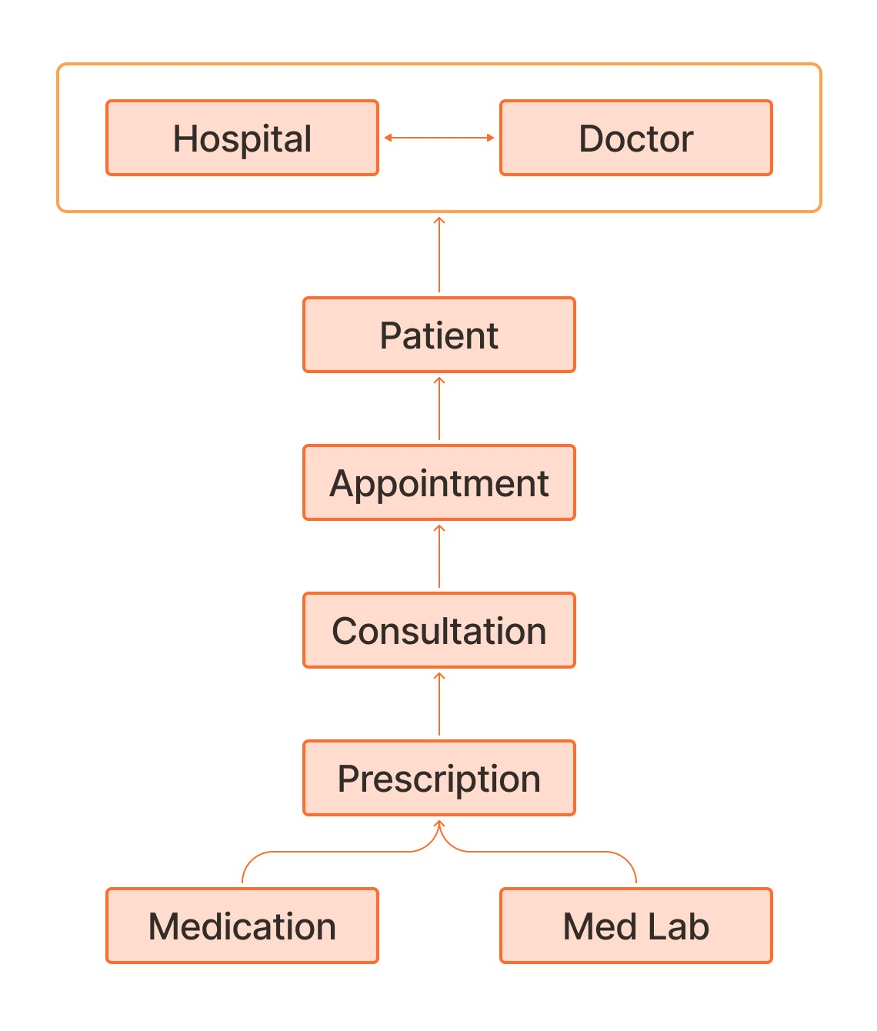

**Fig.6.1** Object Structure

**Appointment**: Keeps track of when patients are scheduled to see doctors.

**Contact**: Stores information about patients, doctors, and other staff members.

**Hospital**: Contains details about the hospital, such as location and services offered.

**Prescription**: Manages information about medicines prescribed to patients.

**Consultation**: Records details of patient consultations with doctors.

**Medication**: Tracks the medications patients are taking.

**MedLabs**: Manages information related to medical tests and results.

**Patient History**: Stores comprehensive medical histories for patients.

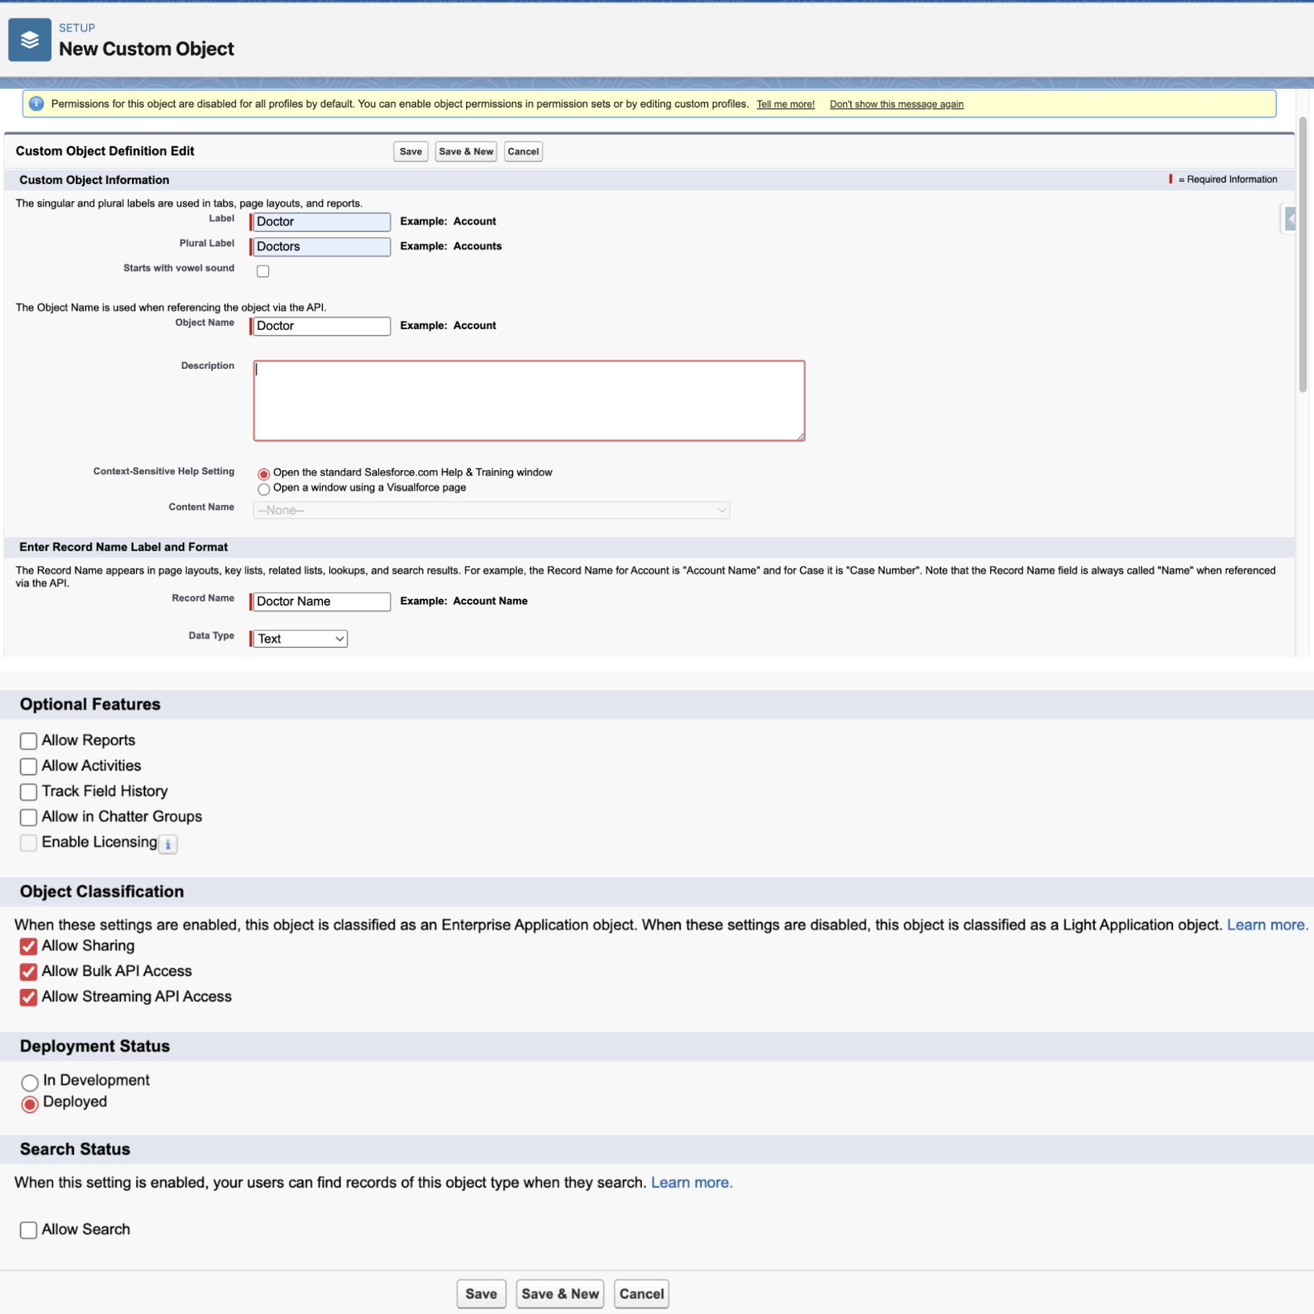

**Fig.6.2** Steps to Create an Object in Salesforce Org.

**How to Create an Object in Salesforce?**

**Step 1** Navigate to Setup Click on the gear icon in the top-right corner of the Salesforce interface, then select "Setup.

**Step 2** Go to Object Manager in the Setup menu, under "Platform Tools," select "Object Manager**.**

**Step 3** Click "Create" in the Object Manager, click on the "Create" button and select "Custom Object".

**Step 4** Fill out Object Details

Enter the label and plural label for your object. These are the names that will appear in the Salesforce interface.

Enter an object name (API name), which Salesforce will use internally.

Choose a Data Type for the Object. Options include Standard, Custom, External, and Platform Event. For most cases, you'll select "Custom."

Optionally, you can enable "Allow Reports" and "Allow Activities" depending on your requirements.

**Step 5** Define Object Properties Enter a description to help users understand the purpose of this object. Choose whether to launch a New Custom Tab Wizard, which allows you to create a tab for this object.

**Step 6** Set Object Security Choose the security settings for the object. You can define who can view, edit, delete, and manage this object. Set the default sharing settings.

Click "Save" Once you've filled out all the necessary details, click "Save" to create the object.

**Step 7** Define Object Fields After creating the object, you can define its fields by clicking on the "Fields & Relationships" tab. Here you can add custom fields, specify their data types, and configure their properties.

**Step 8** Customize Page Layouts and Record Types Customize the layout of your object's records by adding fields, sections, and related lists. You can also create different record types if needed.

**Step 9** Test and Deploy: Before deploying your custom object to production, it's a good idea to thoroughly test it in a sandbox environment to ensure it meets your requirements.

**6.1.1 Appointment Fields**

The appointment object is responsible for keeping track of when patients are scheduled to see doctors. It stores important details such as the patient's name and symptoms, as well as information about the doctor they are scheduled to see.This object also provides functionality to reschedule appointments if needed.

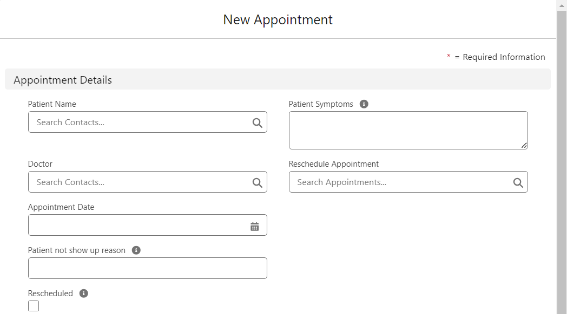**Appointment ID:** A unique identifier automatically generated for each appointment, enabling easy tracking and reference within the system.

**Fig.6.1.1** Appointment Fields

**Patient Name:** The name of the patient for whom the appointment is scheduled. It is the lookup field to Contact.

**Patient Symptoms:** A text field where healthcare providers can note down the symptoms reported by the patient. This information aids in understanding the patient's condition and providing appropriate care during the appointment.

**Doctor:** Indicates the doctor assigned to the appointment. This field is a lookup to contact where patients can select a doctor to whom they want to schedule an appointment.

**Reschedule Appointment:** It is a self-lookup field that can be used to reschedule the appointments if the patient has not shown up on the date appointed.

**Appointment Date:** Specifies the date for the scheduled appointment.

**Patient not show up reason**: A text field where front desk managers or patients can indicate reasons if the patient fails to show up for the appointment. This information can be used for tracking attendance patterns and optimizing scheduling processes.

**Rescheduled:** A checkbox to check whether the record is rescheduled or not.

**6.1.2 Contact Fields**

One single location to store vital data about people interacting with the QuickLink Health system is the Contact object which is a standard object. The Contact object facilitates smooth communication and effective relationship management for all parties involved, including patients seeking medical attention, doctors administering care, and front desk supervisors organizing administrative duties.

**Record Type**: Specifies the type of contact record, providing categorization based on roles within the healthcare system. In QuickLink Health, there are three primary record types:

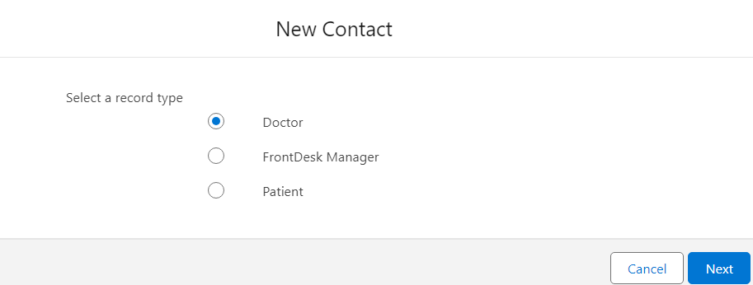

**Fig.6.1.2** Contact Record Type

* **Doctor:** Represents healthcare providers responsible for diagnosing and treating patients. Doctor records typically include specialized information such as medical qualifications, specialties, and availability**.**
* **Name:** The name of the Doctor is captured in this area, making it simple to identify and communicate with them. It makes sure that when patients or administrative staff need to make an appointment or consult a doctor, they can easily find and consult the doctor's information.
* **Consultation Fee:** The consultation fee field specifies the cost associated with an appointment or consultation with the doctor.
* **Specialization:** The specialization field highlights the specific area of medical expertise or focus for each doctor.
* **Phone Number:** The phone field associated with the Doctor record type allows for direct communication with the Doctor.
* **Account Name**: It is a lookup field to Hospital that specifies from which hospital doctor belongs.
* **Front Desk Manager:**

Designates individuals responsible for administrative tasks, appointment scheduling, and patient inquiries at the front desk. Front desk manager records may include details regarding administrative responsibilities and contact information.

* **Name:** The name field captures the identity of the front desk manager.
* **Qualification:** The qualification field highlights the educational background or relevant certifications of the front desk manager.
* **Phone Number:** The phone field provides contact information for the front desk manager, enabling patients to reach out for appointment scheduling, inquiries, or assistance with administrative tasks.
* **Email Address:** Similarly, the email field offers an alternative communication channel for patients to contact the front desk manager.
* **Date of Birth (DOB):** The Date of Birth field captures the birthdate of the front desk manager, providing personal information necessary for administrative purposes within the healthcare facility.
* **Address:** The address field specifies the physical location of the front desk manager, ensuring accurate record-keeping and contact information within the system.
* **Patient:**

Represents individuals seeking medical care and treatment within the healthcare facility. Patient records encompass personal details, medical history, and contact information necessary for providing quality healthcare services.

* **Name:** The name field captures the identity of the patient, facilitating accurate identification and communication within the healthcare system.
* **Date of Birth (DOB):** The Date of Birth field records the birthdate of the patient.
* **Gender:** The gender field specifies the biological sex of the patient.
* **Phone Number**:The phone field captures the contact number of the patient.
* **Weight:** The weight field records the weight of the patient.
* **Height:** The height field captures the height of the patient.
* **Address:** The address field specifies the physical residence of the patient
* **Blood Group:** The blood group field identifies the blood type of the patient, providing critical information for emergency medical care, blood transfusions, and compatibility assessments.
* **Email Address:** The email field offers an additional communication channel for patients to receive medical reminders, appointment notifications, and electronic health records.

**6.1.3 Hospital Fields**

The Hospital object serves as a central repository for storing essential information about the hospital. It can be useful for the information about hospitals.

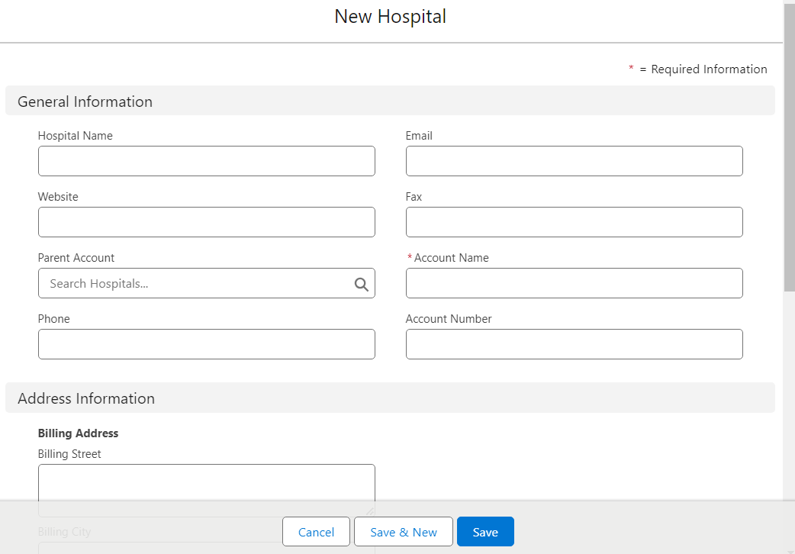

**Fig.6.1.3** Hospital Fields

* **Hospital Name**:

The hospital name field captures the name of the hospital. It is a required field.

* **Website**: The website field provides a link to the hospital's official website, enabling patients and stakeholders to access additional information about hospital services,
* **Fax:** The fax field captures the fax number of the hospital, providing an alternative communication channel for sending and receiving medical documents.
* **Phone Number:** The phone number field includes the contact number for the hospital, enabling patients to reach out for appointment scheduling, inquiries, or assistance with medical concerns.
* **Address:** The address field specifies the physical location of the hospital, including details such as street address, city, state, and zip code.
* **Number of Staff:** The number of staff fields records the total count of healthcare professionals and administrative staff employed by the hospital.
* **Number of Beds:** The number of beds field indicates the total bed capacity available within the hospital, including inpatient and outpatient beds.
* **Customer Priority:** The customer priority field represents the priority level assigned to the hospital based on various factors such as high,low and medium.

**6.1.4 Prescription Fields:**

This custom object manages medication prescriptions. It utilizes a lookup field to the Consultation object, associating prescriptions with specific consultations for accurate record-keeping. Medications can be added to a prescription by utilizing the ‘Related ‘option, which can be accessed after saving the prescription record. The invoice can also be easily generated from this same object.

* **Prescription ID:** A unique identifier automatically generated for each appointment, enabling easy tracking and reference within the system.

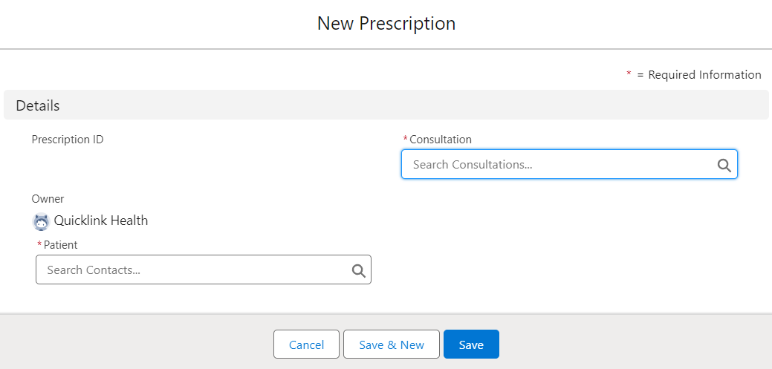

**Fig.6.1.4** (a) Prescription Fields

* **Consultation:** This field can be used to link the specific Prescription record to a Consultation record. It is a lookup field to the Consultation object.
* **Patient:** This field can be used to link the Prescription record to a specific Patient. It is a lookup field to the Contact object.

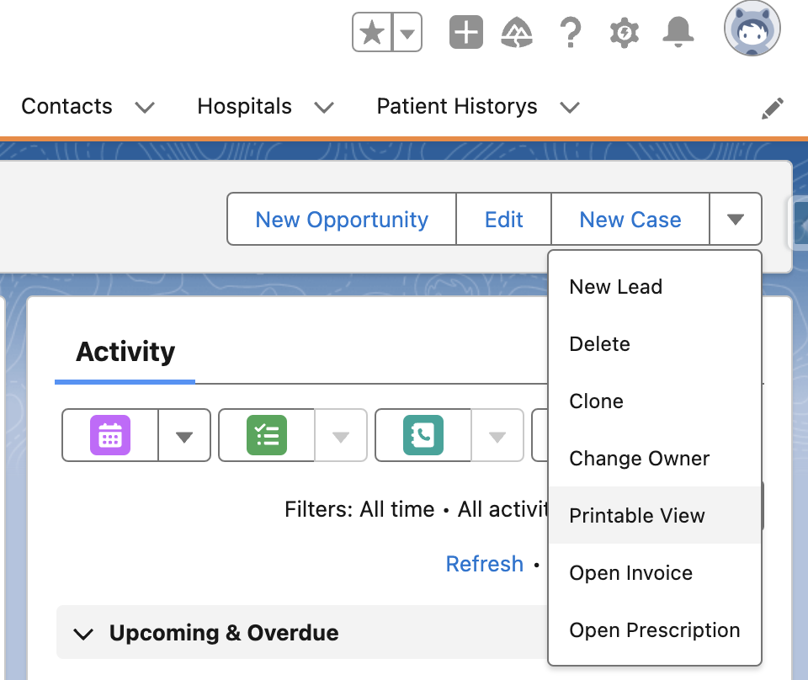

**.6** To Access Prescription & Invoice

**Fig 6.1.4 (**b)To access prescription & invoice

**Accessing Prescription and Invoice Information:** With the prescription object, doctors and staff can quickly find the prescription and billing pages for each patient. This facilitates determining the necessary medications and their associated costs for a patient. Incorporating this functionality into the prescription object allows the healthcare system to ensure that all parties have access to the appropriate information for administering medication and managing payments.

**Prescription Information:**

Imagine seamlessly linking the "Prescription ID" field in the Prescription object to a corresponding PDF document stored in a secure cloud-based repository. This integration would allow researchers to not only access key prescription details within Salesforce but also readily view the complete prescription document with a single click. This eliminates the need for manual document retrieval and streamlines the workflow.

Furthermore, with the prescription PDF readily available, researchers can extract additional insights beyond the core data captured in the object's fields. This could include information like prescribing physician signatures, dosage instructions with specific timings, and potential medication interactions listed on the document. Integrating with PDF documents within the Salesforce ecosystem empowers researchers with a more holistic view of each prescription, enriching their analysis and understanding of medication use patterns.

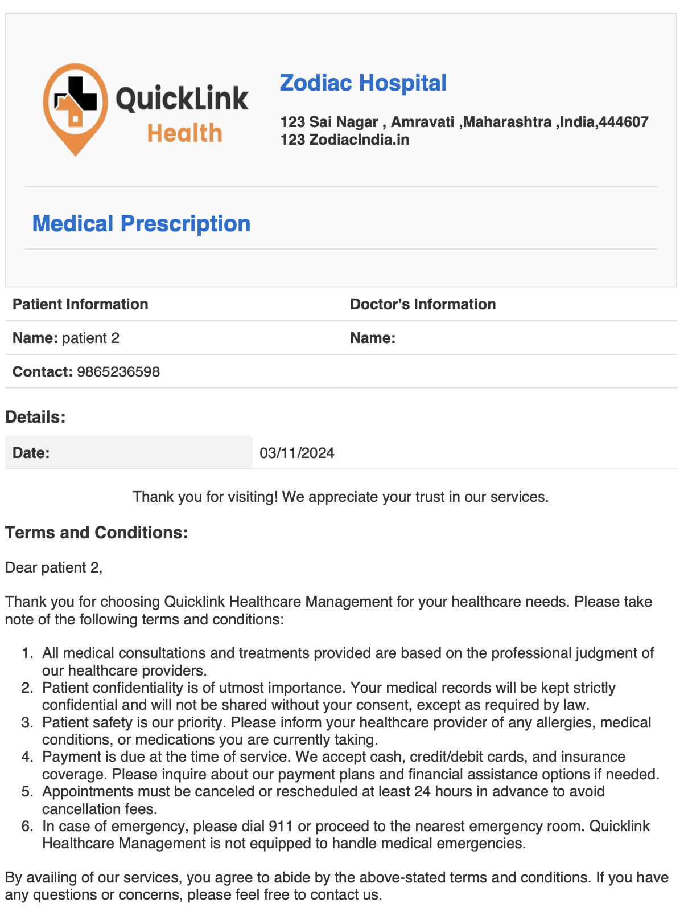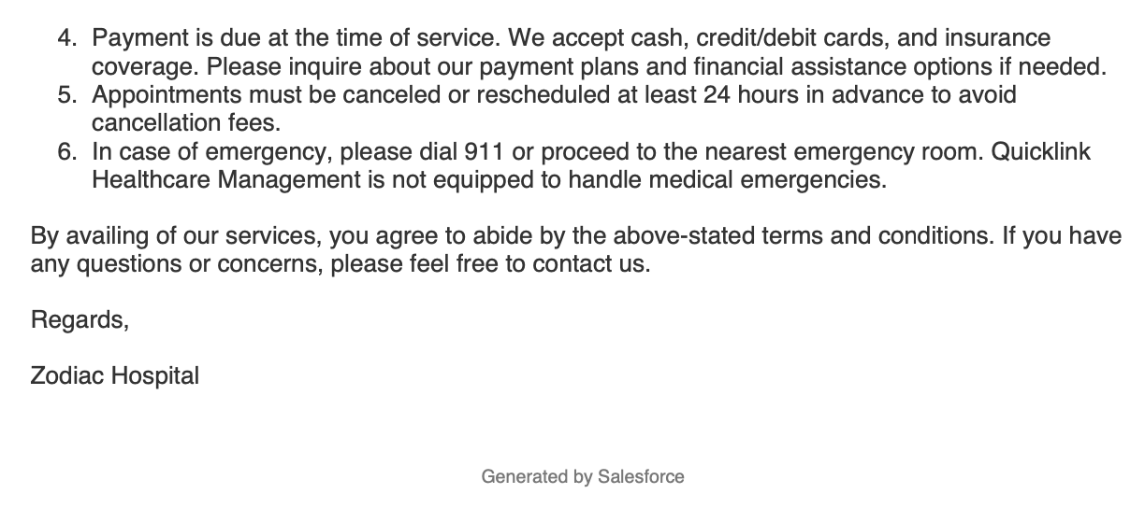

**Fig.6.1.4 (c)** Prescription

**Invoice Information:**

Imagine a scenario where each invoice record within Salesforce is seamlessly linked to its corresponding PDF document stored in a secure cloud repository. This integration would empower users to not only view key invoice details like line items, totals, and due dates but also readily access the full invoice document for detailed reference. This eliminates the need for manual file searches and ensures quick retrieval for both internal teams and clients.

By leveraging PDF integration, organizations can achieve a streamlined workflow for managing invoices within Salesforce. This approach fosters transparency, simplifies record-keeping, and delivers a more professional experience for both internal and external stakeholders.

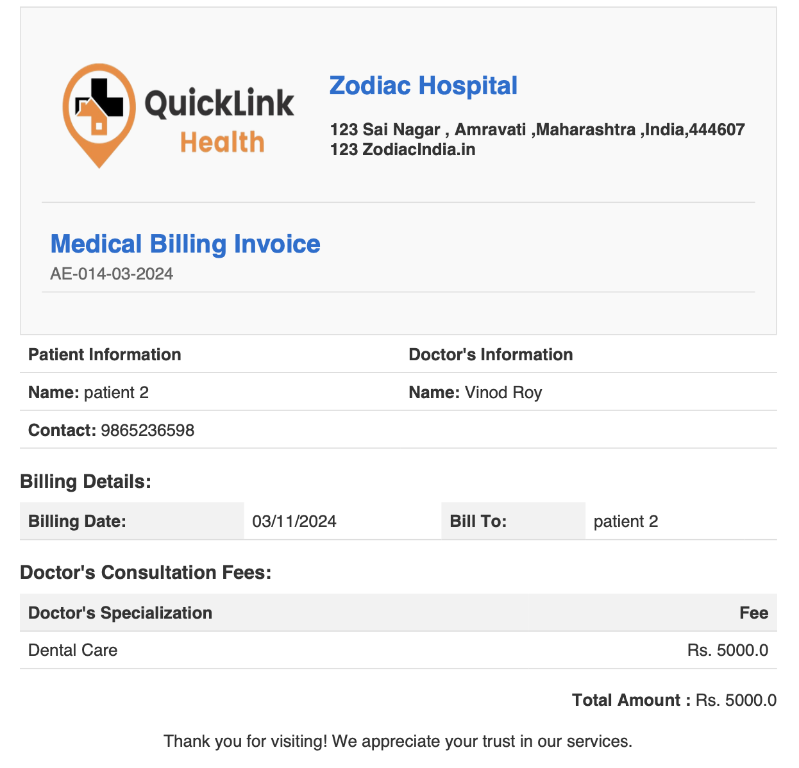

**Fig.6.1.4 (d)** Invoice

**6.1.5 Consultation Fields:**

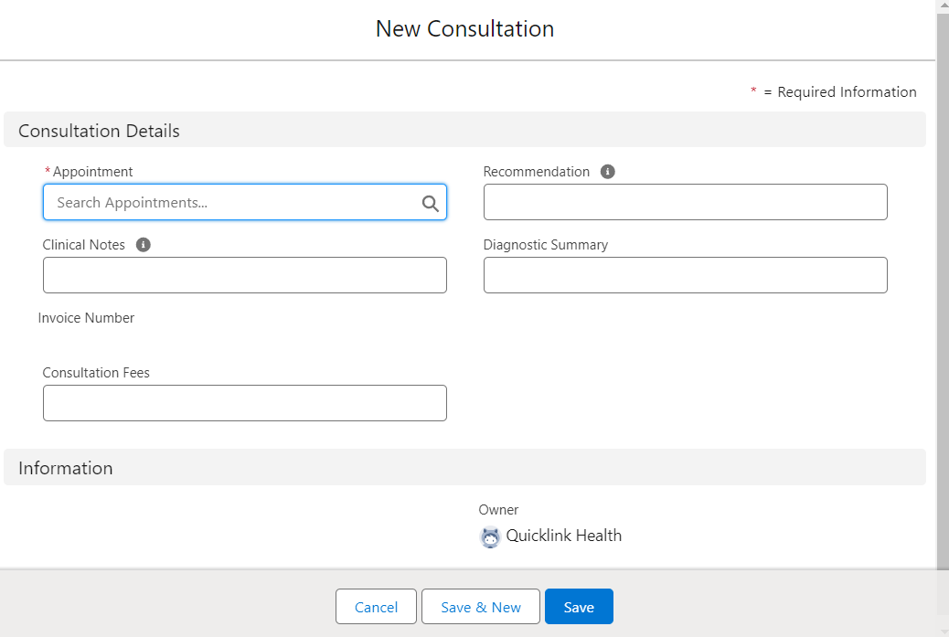

**Fig.6.1.5** Consultation Fields

This custom object represents a specific consultation that occurs during a patient's appointment. It establishes a lookup relationship with the Appointment object, linking it to the specific appointment where the consultation took place.

* **Appointment:** This field is used to link the Consultation record to an Appointment record for which the Consultation is being created. It is a lookup field to the Appointment object.
* **Recommendation:** The Recommendation field is used to recommend the patient about doing some tests like X-ray, ECG, Sonography, etc.
* **Clinical Notes:** The Clinical Notes field can be used to add some notes about the previous findings and observations done by doctors.
* **Diagnostic Summary:** This field is used to write about the diagnosis done on the patient.
* **Consultation Fees:** The Consultation Fees field can be used to mention the fees, that is to be paid by the patient to the doctor.

**6.1.6 Medication Fields:**

This custom object stores information about medications. It employs lookup fields to connect medications to both the Patient History object, providing a comprehensive medical record, and the Prescription object, ensuring clear links between prescribed medications and consultations.

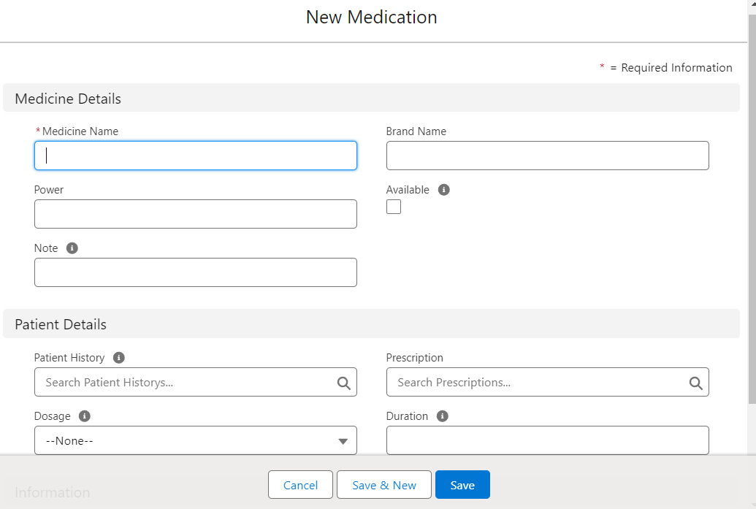

**Fig.6.1.6** Medication Fields

* **Medicine Name:** This field contains the name of the medicine.
* **Brand:** The brand field contains the brand name of the medicine.
* **Power:** The power field contains the power of the medicine.
* **Available:** This is a checkbox type of field. When the checkbox is checked, it shows the medicine is available, and if unchecked the medicine is unavailable.
* **Note:** It is used to write any notes about the medicine.
* **Patient History:** The patient history field is used to access the patient history of the patient. It is a lookup field for the patient history object.
* **Prescription:** This field is used to link the Medication to a Prescription record.
* **Dosage:** It is a picklist type of field, which contains the values of dosage to be taken.
* **Duration:** It contains the details about the duration for which the dosage to be taken.

**6.1.7 Med Labs fields:**

This custom object likely manages data related to medical laboratory tests or procedures. It utilizes lookup fields to connect with both the Consultation and Prescription objects, allowing for association with specific consultations and prescribed medications that may require lab work.

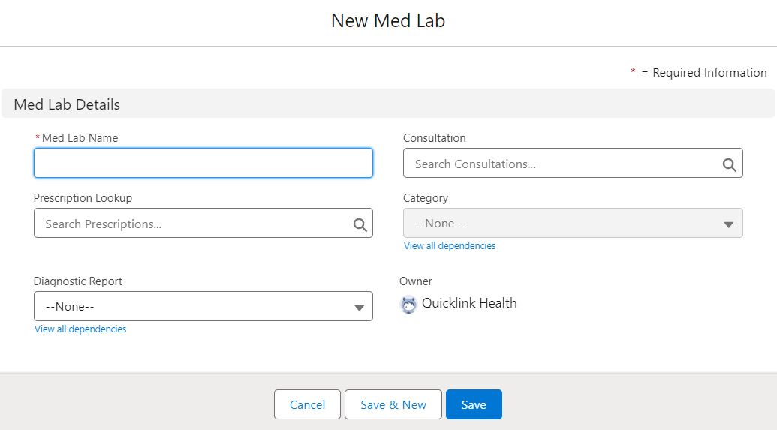

**Fig.6.1.7** Med Lab Fields

* **Med Lab Name:** The med lab name field contains the name of the medical laboratory.
* **Consultation:** The consultation field can be used to link the Med lab record to a Consultation record. It is a lookup field to the Consultation object.
* **Diagnostic Report:** It is a picklist type of field, which contains the names of the reports like X-ray, ECG, Sonography, etc.
* **Category:** The category field is dependent on the Diagnostic report field. Ex. if we select X-ray in the diagnostic report then we get values like Chest X-ray, abdominal X-ray, Spinal X-ray, etc.
* **Prescription Lookup:** This field is having a lookup to the Prescription object and it can be used to link the Med lab record to a Prescription record.

**6.1.8 Patient History Fields:**This custom object stores a patient's medical background and history. It establishes a relationship (lookup field) with the Contact object, enabling the association of a patient's medical data with their contact information.

* **Patient:** This is a lookup type of field, which has a lookup to the Contact. It is used to link the Patient history record to a Patient record on the Contact object.
* **Date of Birth:** The Date of Birth field records the birthdate of the patient.
* **Gender:** The gender field specifies the biological sex of the patient.
* **Allergies:** The details about any kind of allergies should be written in this field.
* **Previous Surgeries:** The details about the previously undergone surgeries should be mentioned in this field.
* **Medical History:** Any other details about previous medical treatments should be entered here in this field.

**7. Code Snippet**

**7.1 Appointment Trigger**

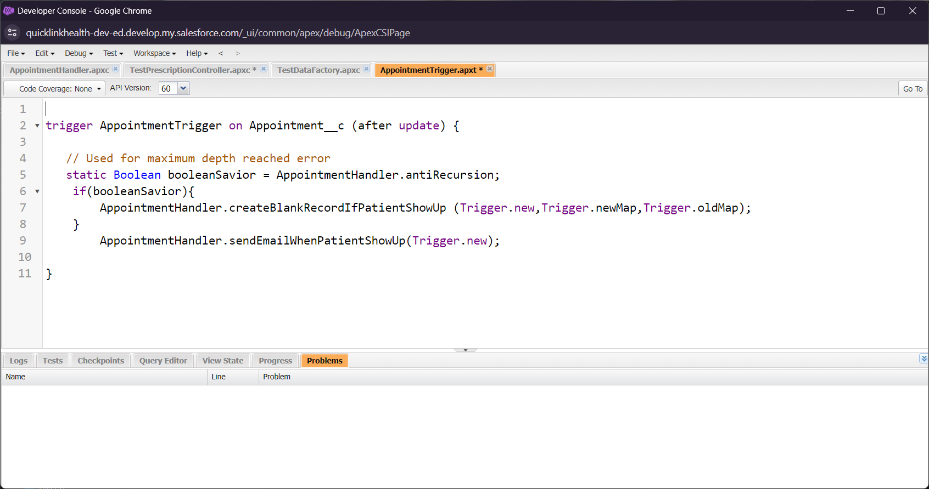

Trigger Definition: This line declares a trigger named AppointmentTrigger on the custom object Appointment__c. It specifies that the trigger should fire after an update operation is performed on records of the Appointment__c object.

* + 1. Static Boolean Declaration: This line declares a static Boolean variable named booleanSavior and initializes it with the value of AppointmentHandler.antiRecursion. This variable is being used to prevent recursion, i.e., to avoid triggering the same logic again and again in a loop.
    2. Recursion Check: This if statement checks if the booleanSavior variable is true. If it is true, it calls the createBlankRecordIfPatientShowUp method from the AppointmentHandler class, passing it Trigger.new, Trigger.newMap, and Trigger.oldMap as parameters. This method likely performs some action related to creating a blank record if a patient shows up.
    3. Send Email: After the recursion check, regardless of whether the recursion is prevented or not, the trigger calls the sendEmailWhenPatientShowUp method from the AppointmentHandler class, passing Trigger.new as a parameter. This method likely sends an email notification when a patient shows up for an appointment.

This trigger is designed to execute certain actions after an update operation is performed on records of the Appointment__c object. It first prevents recursion by checking a static Boolean variable, then executes logic to create a blank record if a patient shows up, and finally sends an email notification when a patient shows up for an appointment. The actual logic for creating blank records and sending emails is implemented in methods defined within the AppointmentHandler class.

* 1. **Prescription Controller**

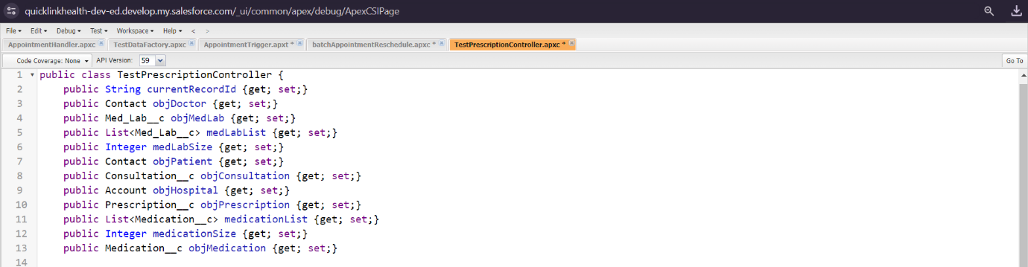

* + 1. Class Declaration: This line declares a public Apex class named TestPrescriptionController. Apex classes encapsulate reusable code that can perform various functions.
    2. Properties: Following the class declaration are multiple public properties defined within the class. These properties represent variables that hold data relevant to the controller's functionality. Each property has a data type and may have a getter (get) and/or setter (set) method associated with it.
* currentRecordId: A String variable to hold the ID of the current record.
* objDoctor: A property of type Contact to hold information about the doctor associated with the prescription.
* objMedLab: A property of type Med_Lab__c to hold information about a medical laboratory.
* medLabList: A property of type List<Med_Lab__c> to hold a list of medical laboratory records.
* medLabSize: An Integer variable to hold the size of the medical laboratory list.
* objPatient: A property of type Contact to hold information about the patient.
* objConsultation: A property of type Consultation__c to hold information about a consultation.
* objHospital: A property of type Account to hold information about the hospital.
* objPrescription: A property of type Prescription__c to hold information about a prescription.
* medicationList: A property of type List<Medication__c> to hold a list of medication records.
* medicationSize: An Integer variable to hold the size of the medication list.
* objMedication: A property of type Medication__c to hold information about a medication.

These properties provide a structured way to store and access data within the controller, allowing it to interact with other components of the Salesforce application, such as Visualforce pages or Lightning components.

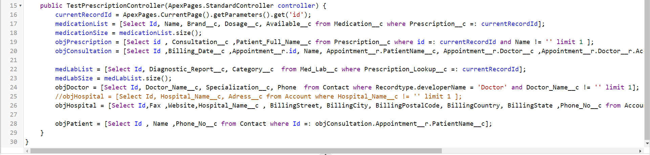

* Constructor Method: This method is a special method in Apex classes that is invoked when an instance of the class is created. In this case, it's the constructor for the TestPrescriptionController class.
* Parameter: The constructor takes a parameter of type ApexPages.StandardController. This is a standard controller provided by Salesforce, which allows the controller to interact with the standard Salesforce UI components, such as Visualforce pages.
* Initialization: Inside the constructor, various properties of the class are initialized with data retrieved from Salesforce using SOQL (Salesforce Object Query Language) queries.
* currentRecordId: Retrieves the ID of the current record from the URL parameters.
* medicationList: Queries Medication__c records related to the current record (Prescription__c =: currentRecordId) and stores them in a list.
* medicationSize: Gets the size of the medication list.
* objPrescription: Queries a single Prescription__c record based on the current record ID.
* objConsultation: Queries a Consultation__c record related to the Prescription__c record.
* medLabList: Queries Med_Lab__c records related to the current record and stores them in a list.
* medLabSize: Gets the size of the medical laboratory list.
* objDoctor: Queries a single Contact record of type Doctor.
* objHospital: Queries a single Account record representing a hospital.
* objPatient: Queries a single Contact record representing the patient associated with the consultation.

These queries fetch data from Salesforce objects related to prescriptions, medications, consultations, medical laboratories, doctors, hospitals, and patients, and populate the corresponding properties of the controller class.

* 1. **Invoice Controller**

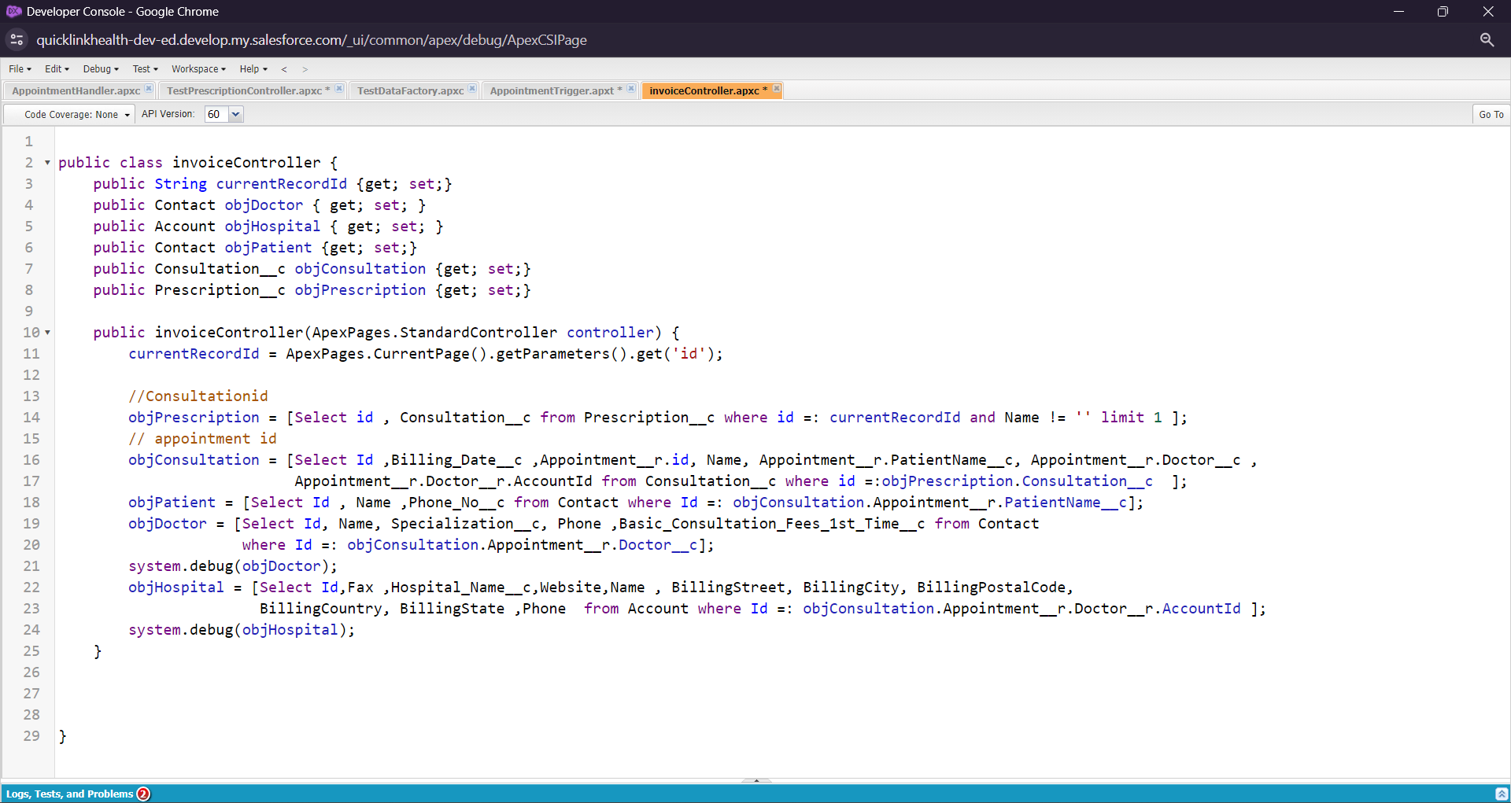

* + 1. Class Declaration: This line declares a class named invoiceController. It will be responsible for handling logic related to invoice generation.
    2. Properties: Public properties are declared to hold data related to the controller's functionality. These properties include currentRecordId to hold the ID of the current record, and properties for objects such as objDoctor, objHospital, objPatient, objConsultation, and objPrescription to store data retrieved from Salesforce queries.
    3. Constructor: The constructor method invoiceController is defined. It takes a parameter of type ApexPages.StandardController, which provides access to the standard functionality of a Visualforce page controller.
    4. Initialization: Inside the constructor, various properties are initialized with data retrieved from Salesforce using SOQL queries:
* currentRecordId: Retrieves the ID of the current record from the URL parameters.
* objPrescription: Queries a single Prescription__c record based on the current record ID.
* objConsultation: Queries a Consultation__c record related to the Prescription__c record.
* objPatient: Queries a Contact record representing the patient associated with the consultation.
* objDoctor: Queries a Contact record representing the doctor associated with the consultation.
* objHospital: Queries an Account record representing the hospital associated with the doctor.
  + 1. Debugging: Debug statements (system.debug()) are used to log the retrieved doctor and hospital records to the debug logs for troubleshooting purposes.

* 1. **Batch Class for Appointment Rescheduling**

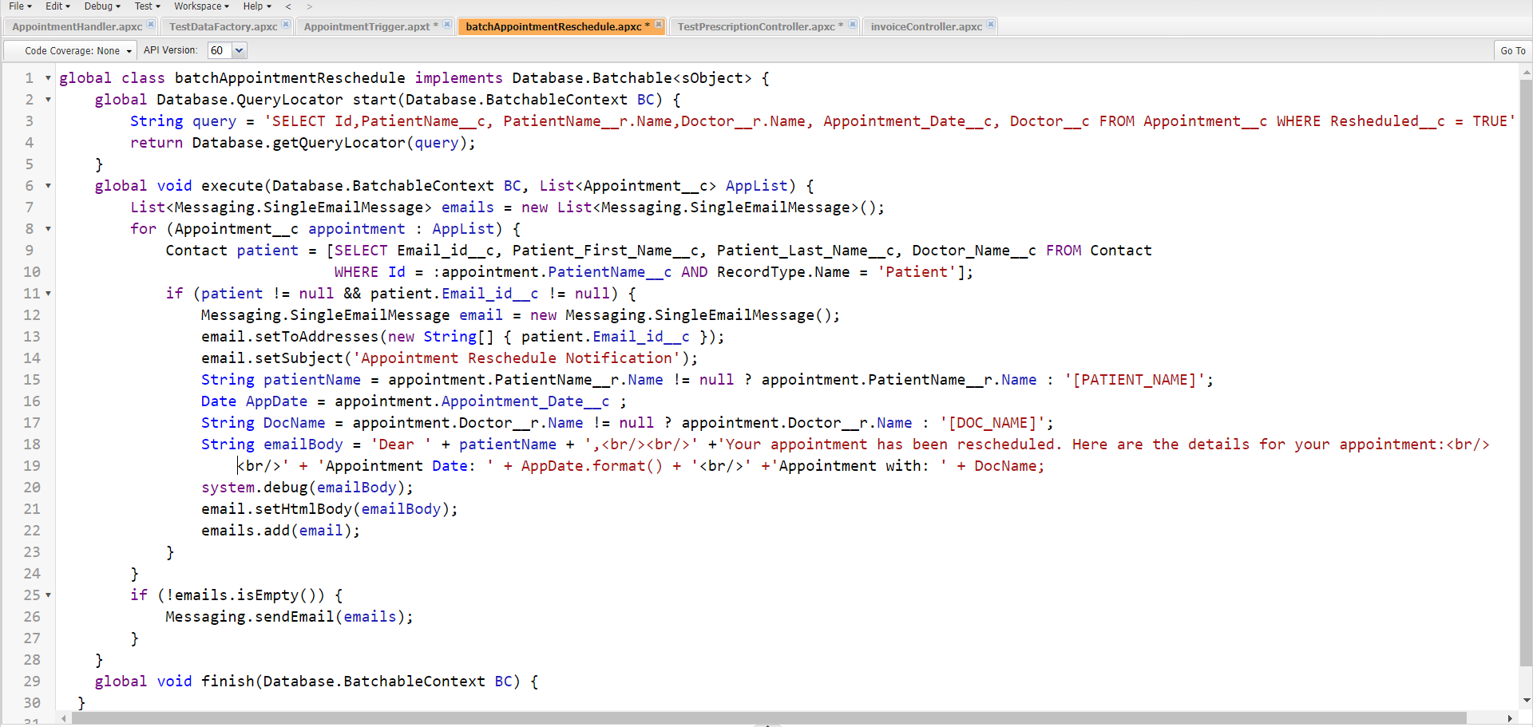

* + 1. Class Declaration: Declares a global class named batchAppointmentReschedule. This class implements the Database.Batchable<sObject> interface, indicating that it can be executed as a batch job on a collection of sObjects.
    2. Start Method: Implements the start method required by the Database.Batchable interface. This method returns a Database.QueryLocator object, which defines the scope of records to be processed by the batch job. In this case, it queries Appointment__c records where the Resheduled__c field is true.
    3. Execute Method: Implements the execute method required by the Database.Batchable interface. This method processes the records retrieved by the start method in batches. For each Appointment__c record in the batch, it retrieves patient contact details and constructs an email message to notify the patient about the appointment rescheduling. The email is added to a list of email messages.
    4. Finish Method: Implements the finish method required by the Database.Batchable interface. This method is called after all batches have been executed. In this case, it is empty and does not contain any post-processing operations.
    5. Email Sending: The constructed email messages are sent in bulk using the Messaging.sendEmail method. This ensures that multiple email notifications are sent efficiently.

1. **Conclusion**

As I approach the end of this exploration of Salesforce CRM in hospital management, a sense of awe washes over me. It's not just the technical prowess of the platform, nor the efficiency it promises, that leaves me breathless. It's the sheer potential for humanization it holds within its circuits. Imagine hospitals transformed from sterile, data-driven machines into havens of personalized care, where AI companions soothe anxieties and doctors wield technology like magic wands, weaving intricate tapestries of well-being. Picture patients not as data points but as individuals with stories etched in their eyes, their needs whispered in the silences between appointments. Salesforce CRM isn't just about streamlining workflows; it's about amplifying the human touch. It's about empowering nurses to anticipate unspoken anxieties, therapists to tailor their methods to the rhythm of each soul, and doctors to make decisions not just with data but with empathy as their compass. This technology isn't a cold, sterile invader; it's a bridge, connecting patients and professionals, departments and stakeholders, hearts and minds. It's a canvas on which we can paint a future where technology doesn't replace humanity but elevates it, where efficiency and compassion dance in harmonious unison.

Consider the transformative possibilities: hospitals metamorphosing from sterile, data-driven entities into sanctuaries of personalized care. Envision AI companions assuaging anxieties, doctors wielding technology as if wielding magic wands, crafting intricate tapestries of well-being. Picture patients not as mere data points but as individuals with narratives etched in their eyes, their needs subtly expressed in the silences between appointments.

Indeed, Salesforce CRM transcends mere workflow streamlining; it embodies the amplification of the human touch. It empowers nurses to anticipate unspoken fears, therapists to tailor their approaches to the unique rhythms of each soul, and physicians to make decisions guided not solely by data but also by empathy as their compass. This technology isn't an alienating force; rather, it serves as a bridge, forging connections between patients and professionals, departments and stakeholders, hearts and minds. It serves as a canvas upon which we can paint a future where technology doesn't supplant humanity but rather elevates it—a future where efficiency and compassion perform a harmonious dance.

As I step back from this research, I don't see numbers and algorithms; I see smiles exchanged at the reception desk, a doctor holding a hand in silent understanding, and a child's eyes lighting up at the sight of their virtual therapist. I see a future where healthcare isn't just a service but a symphony of technology and humanity, orchestrated by the invisible hand of Salesforce CRM.This is an invitation rather than just a research paper. An invitation to embrace the potential of technology, to wield it not as a weapon but as a tool to build a healthcare system that doesn't just heal bodies but also nourishes souls. Let us step into this future, not with trepidation but with open hearts and minds, ready to write a new chapter in the human story, a chapter where technology amplifies the human touch and healthcare becomes not just a privilege but a right enjoyed by all.

**References**

|  |  |
| --- | --- |
| [1] | Keramati, A., & Dastjerdi, M. A Novel Framework for Investigating Organizational Adoption of Ai-Integrated Crm Systems in the Healthcare Sector; Using a Hybrid Fuzzy Decision-Making Approach. *Using a Hybrid Fuzzy Decision-Making Approach*. |
| [2] | Etemad-Sajadi, R., Heo, C. Y., & Clergue, V. (2023). Instilling the core tenets of hospitality in healthcare services: The role of service assurance and social presence. *International Journal of Hospitality Management*, *111*, 103492. |
| [3] | Jalal, A. N., Bahari, M., & Tarofder, A. K. (2021). Transforming traditional CRM into social CRM: An empirical investigation in Iraqi healthcare industry. *Heliyon*, *7*(5). |
| [4] | Vaish, A., Vaish, A., Vaishya, R., & Bhawal, S. (2016). Customer relationship management (CRM) towards service orientation in hospitals: A review. *Apollo Medicine*, *13*(4), 224-228. |
| [5] | Dastjerdi, M., Keramati, A., & Keramati, N. (2023). A novel framework for investigating organizational adoption of AI-integrated CRM systems in the healthcare sector; using a hybrid fuzzy decision-making approach. *Telematics and Informatics Reports*, *11*, 100078. |
| [6] | Hung, S. Y., Hung, W. H., Tsai, C. A., & Jiang, S. C. (2010). Critical factors of hospital adoption on CRM system: Organizational and information system perspectives. *Decision support systems*, *48*(4), 592-603. |
| [7] | Even, A., Shankaranarayanan, G., & Berger, P. D. (2010). Evaluating a model for cost-effective data quality management in a real-world CRM setting. *Decision Support Systems*, *50*(1), 152-163. |
| [8] | Yina, W. (2010, April). Application of customer relationship management in health care. In *2010 Second International Conference on Multimedia and Information Technology* (Vol. 1, pp. 52-55). IEEE. |
| [9] | Yao, X., Li, X., & Su, Q. (2005, June). Study on the customer relationship management and its application in Chinese hospital. In *Proceedings of ICSSSM'05. 2005 International Conference on Services Systems and Services Management, 2005.* (Vol. 1, pp. 188-192). IEEE. |
| [10] | Monem, H., Sharifian, R., & Shaterzadeh, H. CRM Software Implementation Factors in Hospital. |
| [11] | Monem, H., & Behboodian, N. (2011, November). Organizational perspective of CRM implementation factors in hospital. In *2011 International Conference on Research and Innovation in Information Systems* (pp. 1-6). IEEE. |
| [12] | Sharma, A., Rangarajan, D., & Paesbrugghe, B. (2020). Increasing resilience by creating an adaptive salesforce. *Industrial Marketing Management*, *88*, 238-246. |